Name: Shashwat Shah SAP ID: 60004220126

Experiment No: 8

**Aim**: RIP Configuration and Simulation using Packet Tracer

Theory:

Routing Information Protocol (RIP) is one of the oldest distance vector routing protocols, invented in the 1980s. Two versions of the protocol were developed:

Version 1 - supports only classful routing and doesn’t send subnet masks in routing updates. Uses broadcasts for updates.

Version 2- supports classless routing and sends subnet masks in routing updates. This version uses the multicast address of 224.0.0.9to send routing updates.

There is also a version of RIP developed for IPv6 networks called RIPng.

RIP has a default administrative distance of 120. It uses the hop count (the number of routers between the source and destination network) as the metric. The hop count limit is

15. Any route with a higher hop count will be marked as unreachable. 16.

# Implementation :

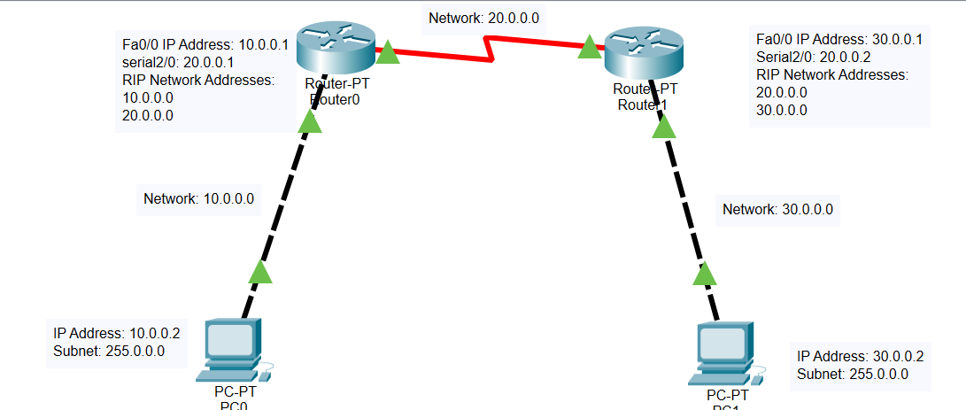

## Router 0:

Router>enable Router#

Router#configure terminal

Enter configuration commands, one per line. End with CNTL/Z. Router(config)#interface FastEthernet0/0

Router(config-if)#ip address 10.0.0.1 255.0.0.0

Router(config-if)#ip address 10.0.0.1 255.0.0.0 Router(config-if)#no shutdown

Router(config-if)#

%LINK-5-CHANGED: Interface FastEthernet0/0, changed state to up

%LINEPROTO-5-UPDOWN: Line protocol on Interface FastEthernet0/0, changed state to up

Router(config-if)#exit Router(config)#interface Serial2/0

Router(config-if)#ip address 20.0.0.1 255.0.0.0

Router(config-if)#ip address 20.0.0.1 255.0.0.0 Router(config-if)#no shutdown

Router(config-if)# Router(config-if)#exit Router(config)#router rip

Router(config-router)#network 10.0.0.0

Router(config-router)#network 20.0.0.0 Router(config-router)#

%LINK-5-CHANGED: Interface Serial2/0, changed state to up

%LINEPROTO-5-UPDOWN: Line protocol on Interface Serial2/0, changed state to up

## Router 1:

Router>enable Router#

Router#configure terminal

Enter configuration commands, one per line. End with CNTL/Z. Router(config)#interface FastEthernet0/0

Router(config-if)#ip address 30.0.0.1 255.0.0.0

Router(config-if)#ip address 30.0.0.1 255.0.0.0 Router(config-if)#no shutdown

Router(config-if)#

%LINK-5-CHANGED: Interface FastEthernet0/0, changed state to up

%LINEPROTO-5-UPDOWN: Line protocol on Interface FastEthernet0/0, changed state to up

Router(config-if)#exit Router(config)#interface Serial2/0

Router(config-if)#ip address 20.0.0.2 255.0.0.0

Router(config-if)#ip address 20.0.0.2 255.0.0.0 Router(config-if)#no shutdown

Router(config-if)#

%LINK-5-CHANGED: Interface Serial2/0, changed state to up

Router(config-if)#exit Router(config)#router rip Router(config-router)#

%LINEPROTO-5-UPDOWN: Line protocol on Interface Serial2/0, changed state to up

network 20.0.0.0

Router(config-router)#network 30.0.0.0 Router(config-router)#

# Conclusion:

Learned about RIP Packet Tracing and implemented using Cisco Packet Tracer